Dear Partners,
Greetings from Kyungpook National University.
We are writing to you with plans for our KNU Online Winter School.
The KNU Online Winter School is from January 17 to 28 (2 weeks). It brings together students and academics for
a unique intercultural experience through lectures on global and Korean issues as well as the Korean language
and culture. All courses are taught either in English or Korean, and you will take courses with other participants
from all over the world.

Program Overview
- Eligibility: A student who is currently enrolled in university/college and pursuing a bachelor’s degree
- Duration: January 17 – 28 (2 weeks, 3 credits)

Application/Payment Deadline: December 10, 2021

Curriculum
Korean Language (Pick 1) | Cultural Experience
- Korean Language 1 (Basic)  - Korean Language 2 (Intermediate) | - Hanbok Try-out  - K-Movie  - Virtual Excursion | - Korean Food  - Taekwondo  - K-pop

Application Process
- Students from partner universities must be nominated by their home universities via knusummer@knu.ac.kr before submitting the online application - Students from non-partner universities must send 'name/home university name/nationality' directly to knusummer@knu.ac.kr
- Complete the online application by December 10, 2021 (Application site will be sended later)
- Complete the payment and send a copy of the program fee payment receipt to knusummer@knu.ac.kr by December 10, 2021
- All admitted students receive a copy of admission via email in end-December

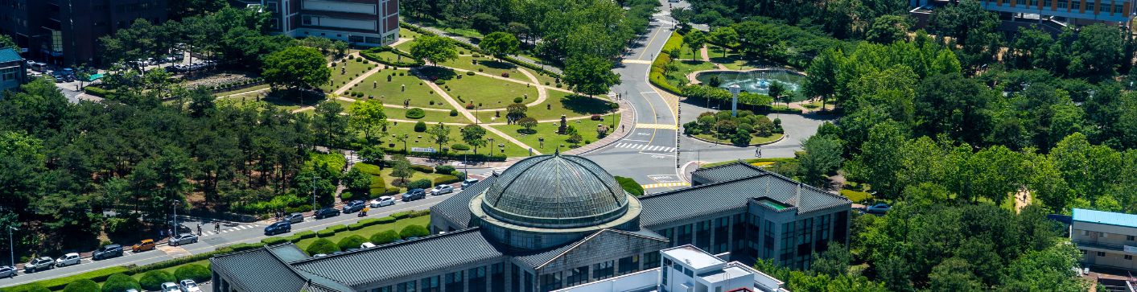

Program Fee
Partner University | 100 USD
Non - Partner | 130 USD
- Make sure program fees are transferred under the name of the participant
- Transfer commission must be paid by applicants

Fee Payment Account
- Daegu Bank
- Kyungpook National University Branch 111, Oksan-Ro, Buk-Gu, Daegu, South Korea
- Account number : 532-10-123035-5
- Swift Code : DAEBKR22
- Name of Depositor : Student's name (same as application form) or Home university name (with applicants list)

Cancellation & Refund Policy
- Except for instances of serious illness or other acceptable reasons determined by the university, there will be no refund for cancellation. Cancellation requests should be made by email to knusummer@knu.ac.kr
- On or before December 24: 100% refund
- From December 25 to January 13: 50% refund
- After January 14: No refund
- Please note that bank-transfer charges will be deducted from the total amount refunded.

Contact
- Office of International Affairs
- Kyungpook National University 80 Daehakro, Buk-Gu, Daegu, Republic of Korea, 41566
- Email: knusummer@knu.ac.kr/ Tel: +82-53-950-2416

Best regards,
Office of International Affairs
Kyungpook National University
Daegu, South Korea

